Protocol for Treating Vulvodynia Using Low-Intensity Shockwaves
Device: MoreNovaPro - Li50F Linear Transducer
Document Version: 1.0
Date: 30/12/2025
1
. Purpose and Scope
This protocol provides a standardized treatment plan for the use of low-intensity
shockwave therapy to manage vulvodynia, a chronic vulvar pain condition without an
identiﬁable infectious, dermatologic, or neurologic cause. It is intended for qualiﬁed
healthcare providers using the MoreNova device with the Li50F transducer to target the
vulvar vestibule and surrounding vulvar tissues. This protocol applies to females aged 18–
70 years who are clinically diagnosed with provoked, unprovoked, or mixed vulvodynia and
who have experienced persistent vulvar pain, burning, or discomfort for a duration of three
months or longer.
2
. Introduction
Low-Intensity Extracorporeal Shockwave Therapy (LiESWT) is a non-invasive technology
that delivers acoustic waves to stimulate tissue regeneration, enhance local blood
circulation and support tissue remodeling, which may contribute to modulation of pain
perception. In women with vulvodynia, LiESWT is applied to the vulvar vestibule and
surrounding tissues with the aim of reducing chronic vulvar pain and burning sensations
by improving microvascular function and supporting tissue remodeling. For further
information on clinical rationale and emerging evidence, visit our Clinical Data Center.
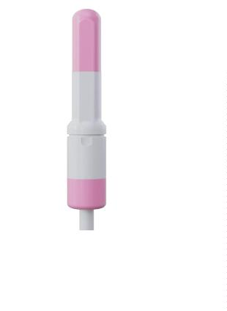

Device Overview:
MoreNova is a portable Electromagnetic (EM) Low-Intensity Shockwave (LISW) device
designed to stimulate angiogenesis, enhance microcirculation, and support tissue
regeneration in targeted tissues, improving outcomes for various conditions in men and
women.
3
. Background Condition Overview:
•
Vulvodynia is a chronic vulvar pain condition characterized by burning, stinging,
irritation, or rawness of the vulvar area, lasting three months or longer without an
identiﬁable infectious, dermatologic, or neurologic cause.
•
The condition may be provoked, unprovoked, or mixed, and is thought to involve
altered peripheral nerve sensitivity, local inﬂammatory processes, and impaired
microcirculation of the vulvar tissues.
Mechanism of Action
•
Low-intensity shockwave therapy promotes neovascularization, enhances local
blood ﬂow, and supports tissue regeneration. These eﬀects may contribute to
reduced neurogenic inﬂammation, modulation of pain signaling, and improved
tissue health in the vulvar vestibule, thereby alleviating chronic vulvar pain and
discomfort.
4
. Patient Selection Criteria Inclusion Criteria:
•
•
Women aged 18–70 years.
Clinically diagnosed with vulvodynia (provoked, unprovoked, or mixed type) by a
qualiﬁed gynecologist or vulvar pain specialist.
•
•
Persistent vulvar pain, burning, stinging, or discomfort for ≥ 3 months.
No identiﬁable infectious, dermatologic, or neurologic cause after appropriate
evaluation.
•
Symptoms refractory to or insuﬀiciently managed by conservative treatments
(e.g., topical therapy, oral medications, pelvic ﬂoor physical therapy).

Exclusion Criteria:
•
•
Active vulvovaginal infection or inﬂammatory condition.
Open wounds, ulcerations, or active dermatologic lesions in the vulvar or vestibular
area.
•
•
•
•
•
Recent vulvar, vaginal, or pelvic surgery (< 6 months).
Known blood coagulation disorders or active anticoagulant therapy.
Pregnancy or lactation.
History of pelvic or external genital irradiation within the past year.
Severe or uncontrolled chronic pain conditions or signiﬁcant pelvic ﬂoor
hypertonicity.
•
Presence of implanted electronic or metal medical devices sensitive to
electromagnetic radiation.
5
. Pre-Treatment Screening
To determine the patient's suitability for LiESWT, conduct the following:
•
•
•
•
Comprehensive medical, gynecological, and pain history, including symptom
duration and triggers.
Focused vulvar and vestibular examination to localize pain and exclude active
pathology.
Diagnostic evaluation as indicated to rule out infection or other identiﬁable causes
(e.g., vaginal swabs, cultures, or biopsy when clinically warranted).
Assessment of pain severity and functional impact using validated pain or vulvar
symptom questionnaires, when available.

6
. Treatment Protocol Preparation:
•
•
Conduct a thorough medical history and gynecological examination.
Counsel the patient about the procedure, beneﬁts, risks, and expected outcomes.
Procedure:
•
•
•
•
Number of Sessions: 6-8 sessions based on severity.
Session Frequency: Twice per week.
Session Duration: 17 minutes. (2 passes around the vestibule)
Applications Per Session: 2.
The rotation pattern:
1
2
. Vulvar vestibule, right.
. Vulvar vestibule, left.
•
•
Shocks Per Application: 1000.
Total Shocks Per Session: 2000.
Treatment Parameters:
•
•
Energy (HV) Settings: 1.9 kV.
Frequency (FRQ): 2.0 Hz.
Post-Treatment Care:
•
Advise patients to avoid sexual activity, tampon use, and other forms of local
mechanical irritation for 24 hours following treatment.
Recommend adequate hydration and gentle vulvar hygiene.
Instruct patients to report any adverse events, including increased pain, skin
irritation, or unusual discomfort.
•
•
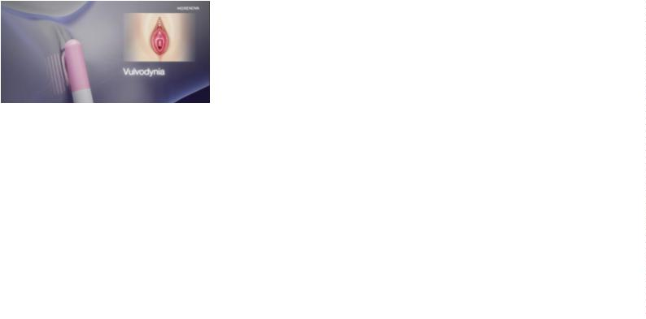

7
. Treatment Areas and Techniques
The treatment focuses on the following anatomical areas:
•
•
Vulvar vestibule, including the peri-introitus region.
Right and left vestibular areas, corresponding to patient-reported pain localization.
Ensure correct Li50F transducer placement on the external vulvar tissues only. Apply
gentle, uniform contact pressure using suﬀicient coupling gel to ensure acoustic
transmission. Perform two circumferential passes around the vestibule, moving
systematically to cover all designated areas in a controlled sequence. Avoid direct
application over open skin, ulcerations, or areas of acute inﬂammation.
8
. Patient Comfort and Safety
To ensure patient comfort and safety during the procedure:
•
•
•
Position the patient in a supine or lithotomy position for optimal access.
Use conductive gel for eﬀective shockwave transmission and minimal discomfort.
Continuously monitor patient feedback during the session and adjust settings if
needed.
•
Treatment should be discontinued if the patient experiences intolerable pain or
adverse skin reactions.
9
. Treatment Outcomes and Follow-Up Expected Results:
Patients typically experience symptom improvement within 3–6 weeks of starting
treatment. Regular assessments are recommended to evaluate progress.
Follow-Up Visits:
Schedule bi-weekly follow-ups to monitor patient outcomes and adjust the treatment plan
as needed.
Long-Term Maintenance:
For sustained improvement, consider maintenance sessions every 3–6 months based on
individual needs.

10.
Visuals and Diagrams
Li50F
•
Anatomical areas being treated.
•
Rotation pattern for Transducer placement.
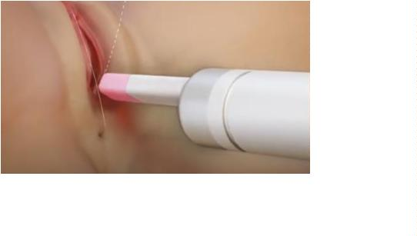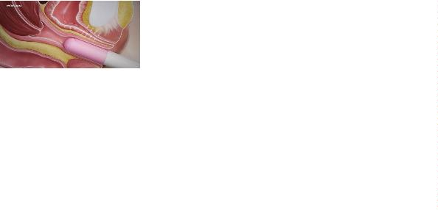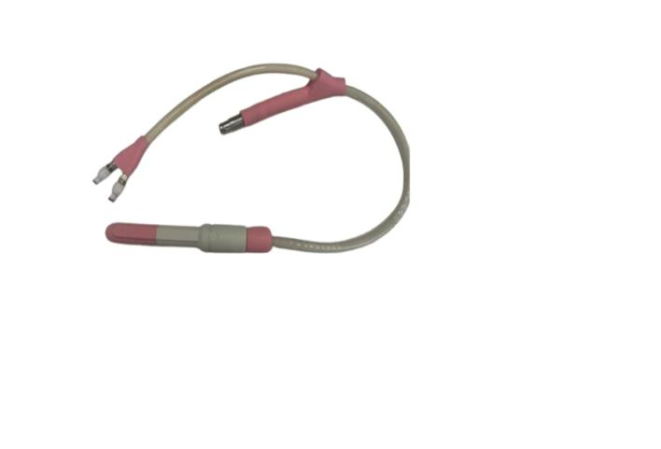

11.
Quality Control Device Calibration:
•
Verify device settings before each session.
•
The MoreNova Device recognizes preprogrammed parameters, ensuring correct
settings are automatically applied.
Clinician Training:
•
•
Ensure all operators are thoroughly trained in the use of the MoreNova Device and
Li50F Transducer.
Clinicians should be familiar with this protocol and review the "Instructions for Use"
provided by the manufacturer.
Checklist for Each Session:
•
•
•
Conﬁrm that the patient meets the inclusion criteria and has no contraindications.
Ensure the device and Transducer are clean, sanitized, and function correctly.
Conﬁrm that the Transducer placement aligns with the anatomical areas speciﬁed
in the protocol.
12.
References
For clinical studies and additional resources, visit the Initia Clinical Data Center.

